Pruett, Sol article, Civil War
The following three short pieces were excerpted from a longer article reporting the wounded in the area regiments of the Civil War :

Southern Recorder, Mar. 8, 1864
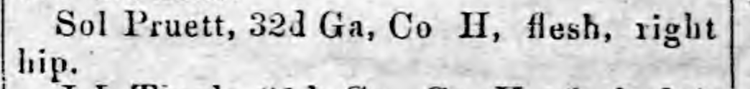
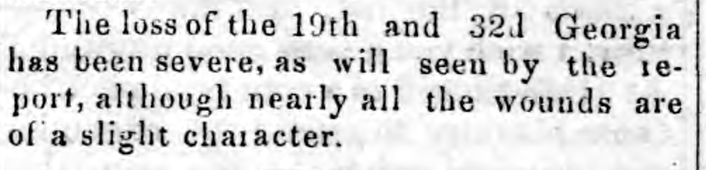

Submitted by Elaine Pruett 9/13/12

